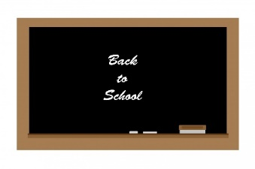 

**Welcome to the 2022-2023 School Year**

The Boonton High School HSA would like to welcome you back to another school year. We also want to thank you for your support during the 2022-2023 school year. It is our first year on the board. With your help, we hope to make it a successful year!

As you know, the goal of the HSA is to provide funding to support and supplement the educational experience for all students and staff at Boonton High School. The key to a successful HSA is the involvement of our Entire School Community…. not just parents or just staff. We need to work together, as a team, to make a difference for the students, staff and school as a whole!

Fundraising is a major task for our organization. We are hoping to make it as easy as possible and raise the most funds we can. We know how tough fundraising is when not only is the HSA asking, but sports/other school clubs, outside of school clubs, and even your own children fundraising for their school or outside activities.

It is our hope to do a few meaningful fundraisers again this year, that will raise us a significant amount of money to make a difference for Boonton High School Students and Staff. The fundraisers we have planned so far are a Calendar Raffle, Disney Pass Raffle and Dinners to Go and Dine to Donate. In addition, our Membership Dues Drive is also part of our fundraising efforts.

As long as our funds permit, we would like to continue providing Scholarships to graduating seniors, offering grants for teachers, and providing funds for assemblies, if the need arises. In addition, we will be hosting a Holiday Teacher Luncheon, and Teacher Appreciation Week treats, again this year.

Finally, we would love to hear your suggestions or new ideas. If you heard of a successful fundraiser, let us know. We will definitely look into it. If you have an idea for an assembly or fun event, let us know. As long as we have the funds, we want to make school exciting for both the students and staff!

We hope we can count on your support again this year, to make this another successful one! If you have any questions or concerns, please let us know.

Thank you! We hope you enjoy the 2022-2023 School Year!

Melissa Morales, Treasurer/Secretary Karen Bendig, President Jen Darling, VP